Columbia University Graduate School of Architecture, Planning and Preservation A4625-1: Tension/Compression Surfaces in Architecture: Tactile Methods For Architects, Fall 2019
Wed 5:00-7:00 in room 114, Avery Hall
Robert Marino, Adjunct Associate Professor, rem3@columbia.edu, James Nicolas Brillon, Teaching Assistant, jnb2149@columbia.edu

COURSE SUMMARY

As D’Arcy Thompson has expostulated in his 1917 treatise “On Growth and Form”, the Nature’s smallest unit is the cell, and the cell is wholly dependent on its wall as its basic method of containment. The elasticity of the cell’s wall in combination with its internal pressure determines its form. It simultaneously provides enclosure and structure, providing protection, rigidity, and permanence. It is at once the smallest and the most efficient form in Nature. As a form the cell’s walls exhibit continuous minimal tension in all directions, thereby enclosing a maximum volume through the use of minimum surface area. This requirement for efficiency was a quality central to the modern architect’s ethos, and brought Thompson’s book to prominence within the profession.

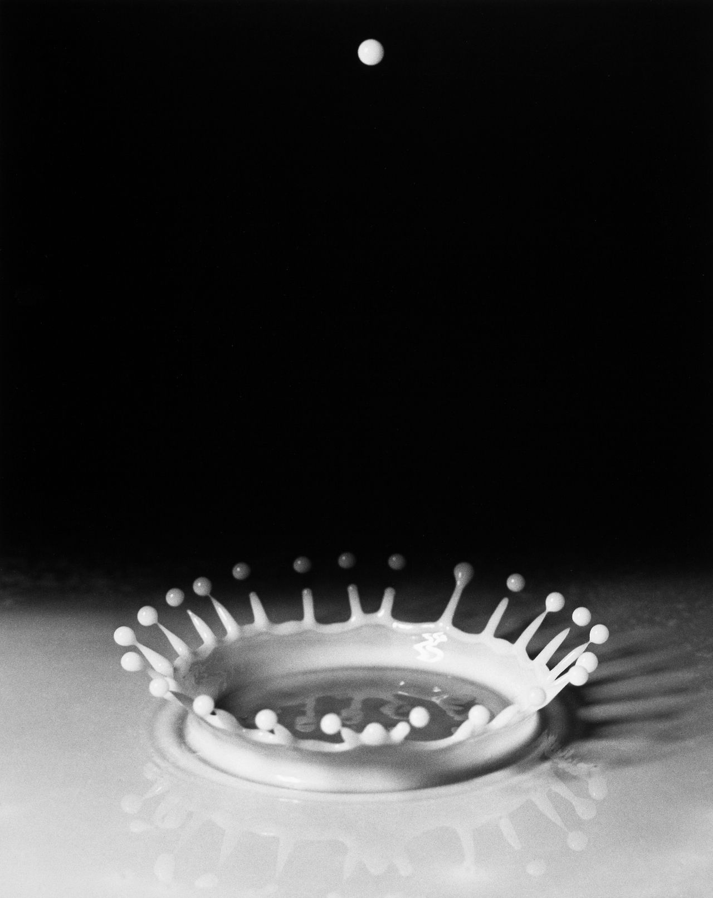
Harold Edgerton, Milk Drop Coronet Splash, 1936

Pure tension surfaces have had significant uses in architecture perhaps best exemplified by the work of Frei Otto, architect of the remarkable Munich Olympic Stadium. In work such as this the elastomeric materials of construction are used in pure tension in all directions and the resulting forms are a product of the myriad end conditions required by program and site.
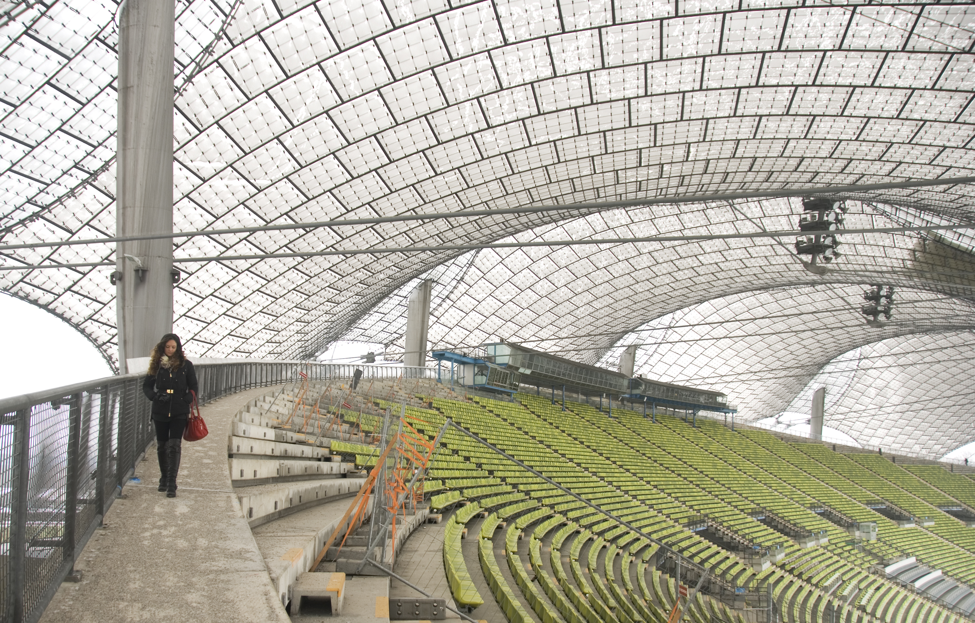
Munich Olympic Stadium, Frei Otto, Architect

Inverted forms of pure tension, in the Earth’s gravitational field, have been employed as compression shells, providing shelter with minimal material expenditure. Pioneers in this method include Antoni Gaudi, Eladio Dieste, and Felix Candela.

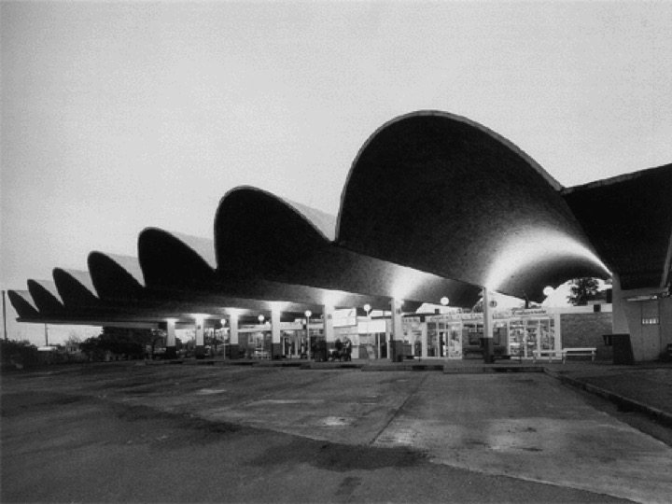
Eladio Dieste Salto Bus Terminal

This architectural history will form a beginning point for our semester’s work. Research however, will be conducted through continuous analogous modeling methods. Surfaces will be determined through the interactions of forces and materials and a methodology for surface generation will be determined.

This tactile knowledge will then be used to produce shell, or other types of structures that, when combined, create shelter at model scale. End conditions will be pre-determined and fixed, allowing stabile beginning points for the semester projects. It is envisioned that the primary modeling techniques shall be casting techniques, although all other methods for shell construction can be considered.

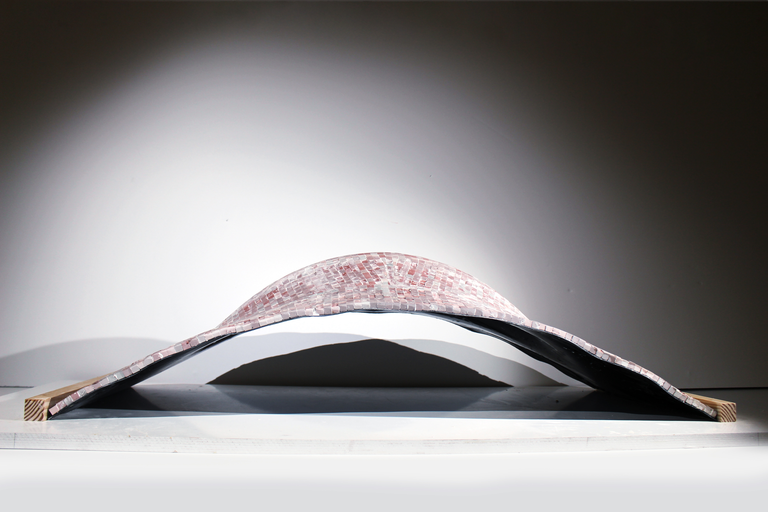
Whale Hump Tile Shell, William Barker, Min Chen, Jake Rosenwald, Fall 2018

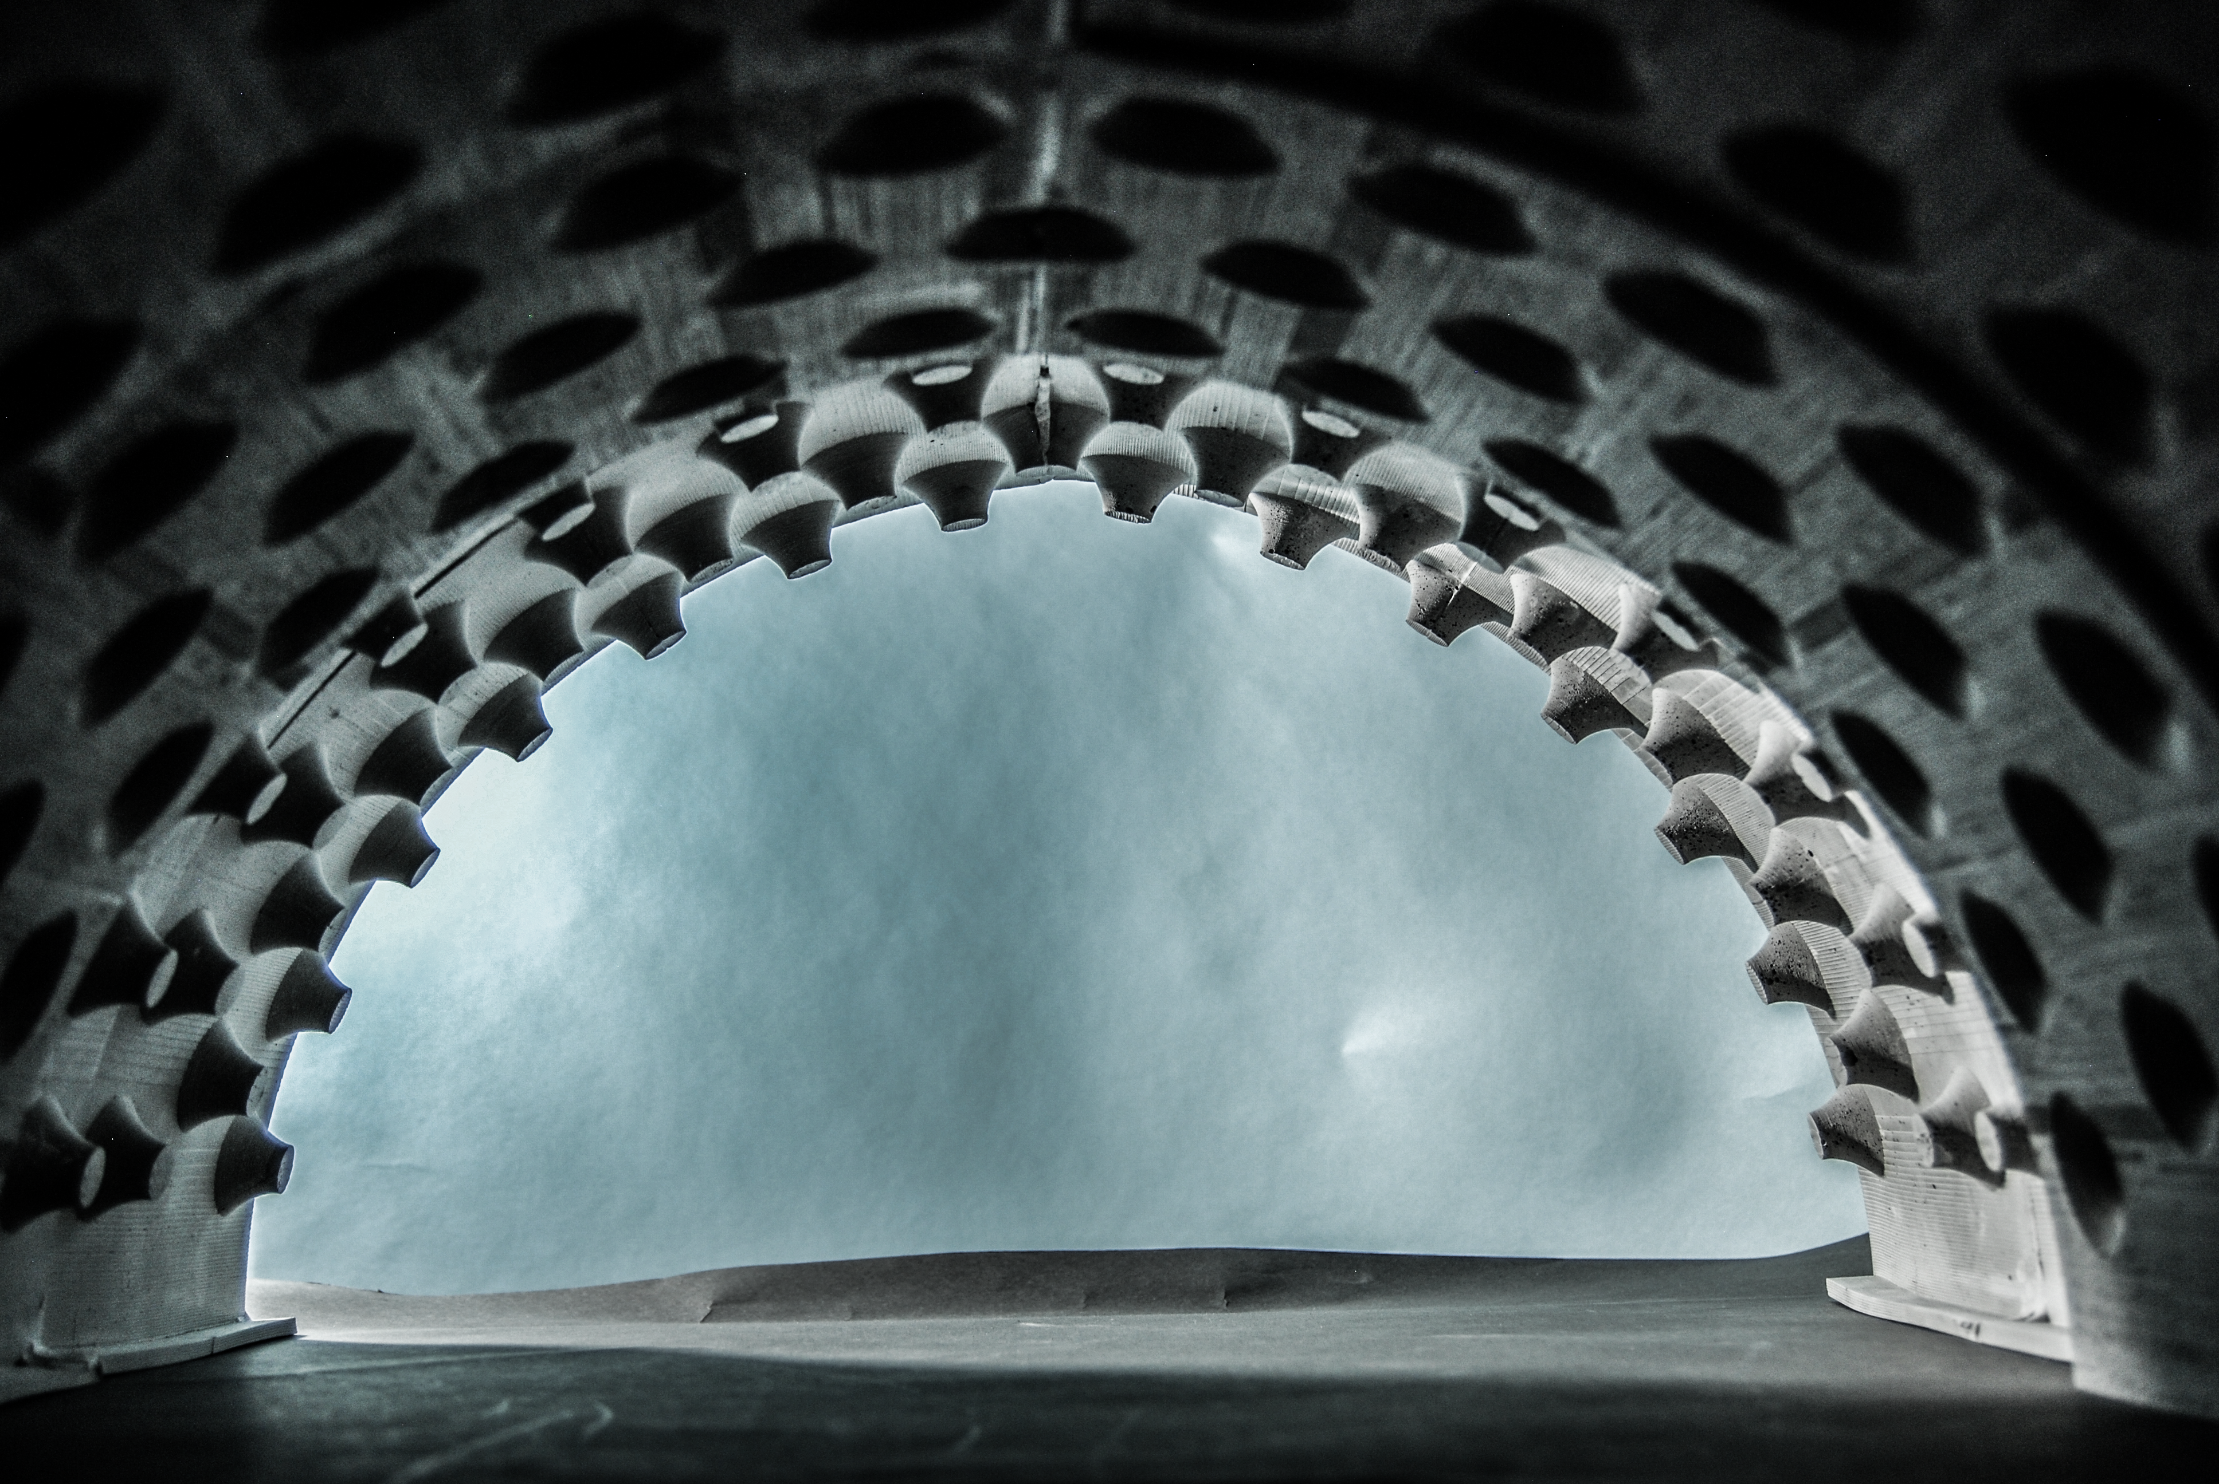
Space Frame Shell, Luisa Canuto, Timothy Clark, Fall 2018

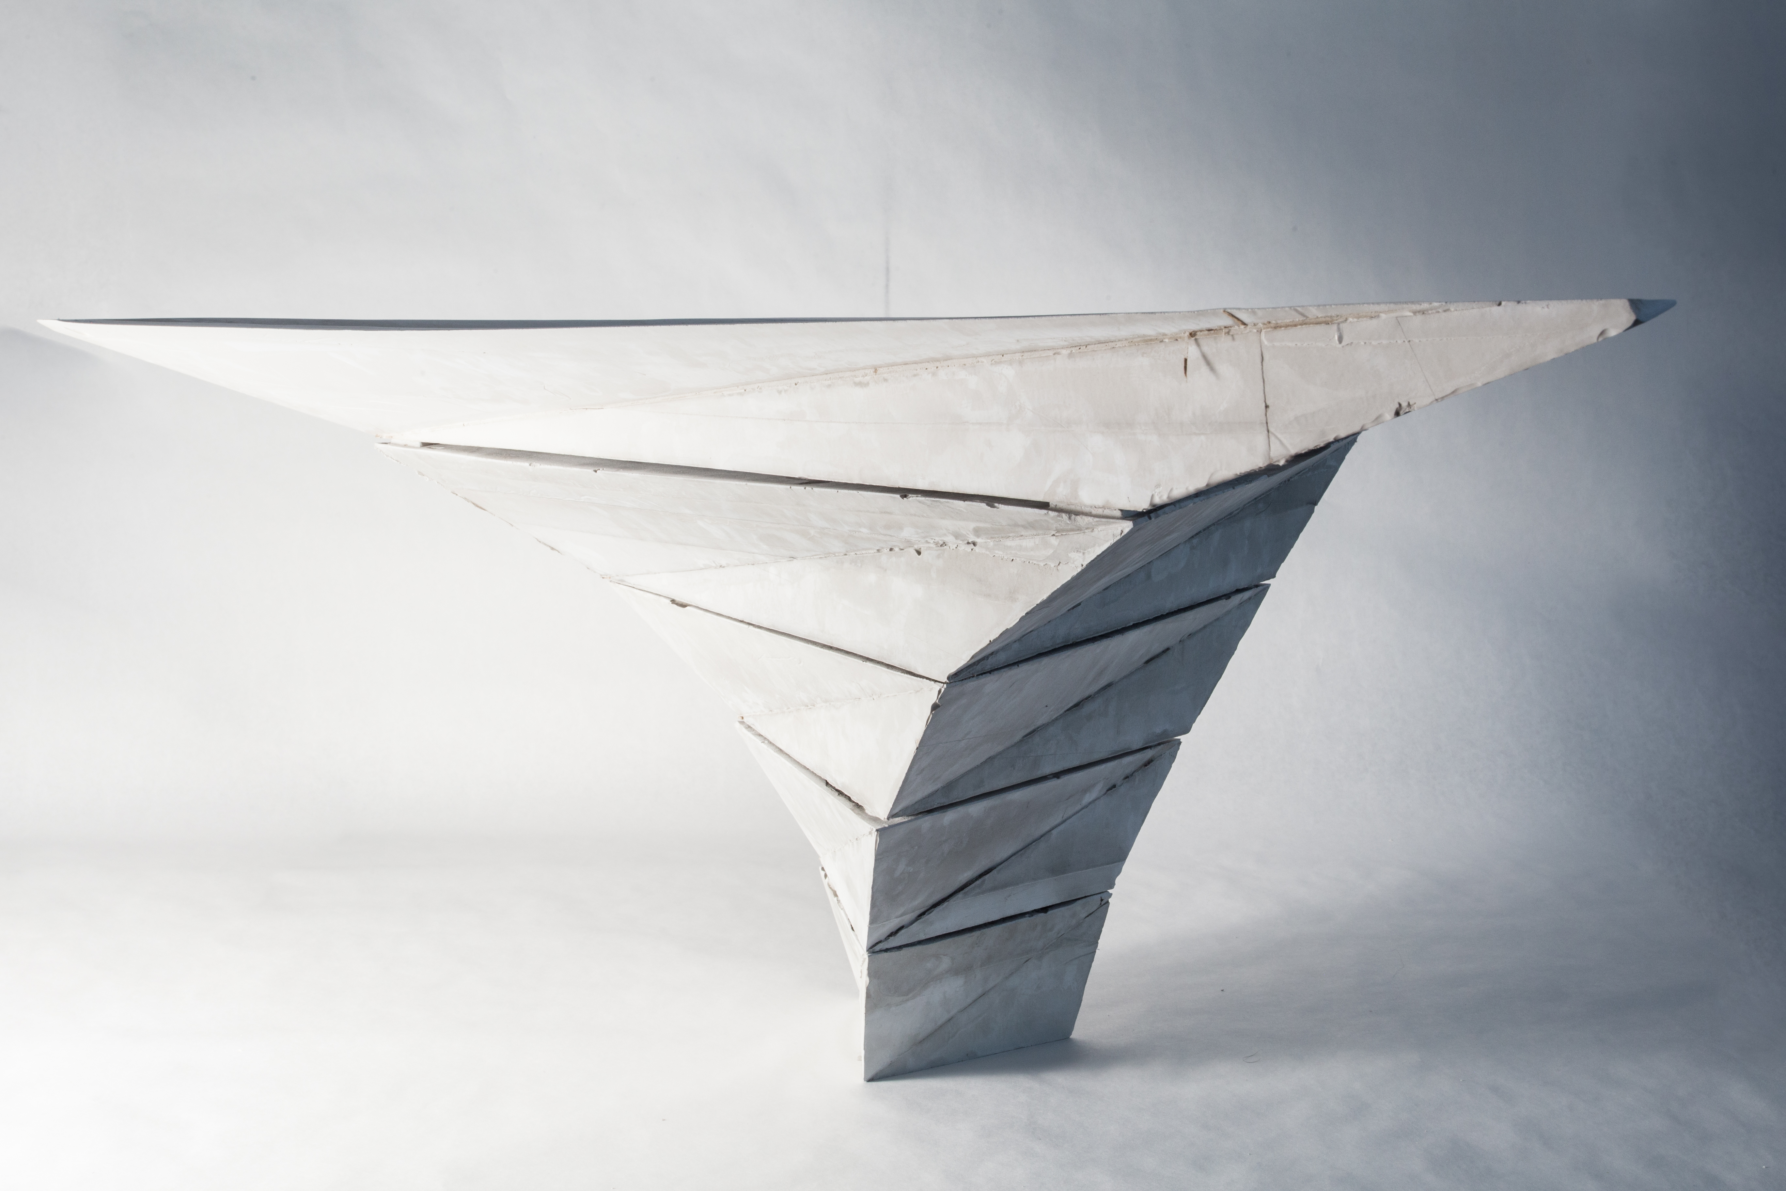
Segmented, Self Generating Shell Extension, Russel Einbinder,
Samuel Guenin, Emma Ross, Fall 2018

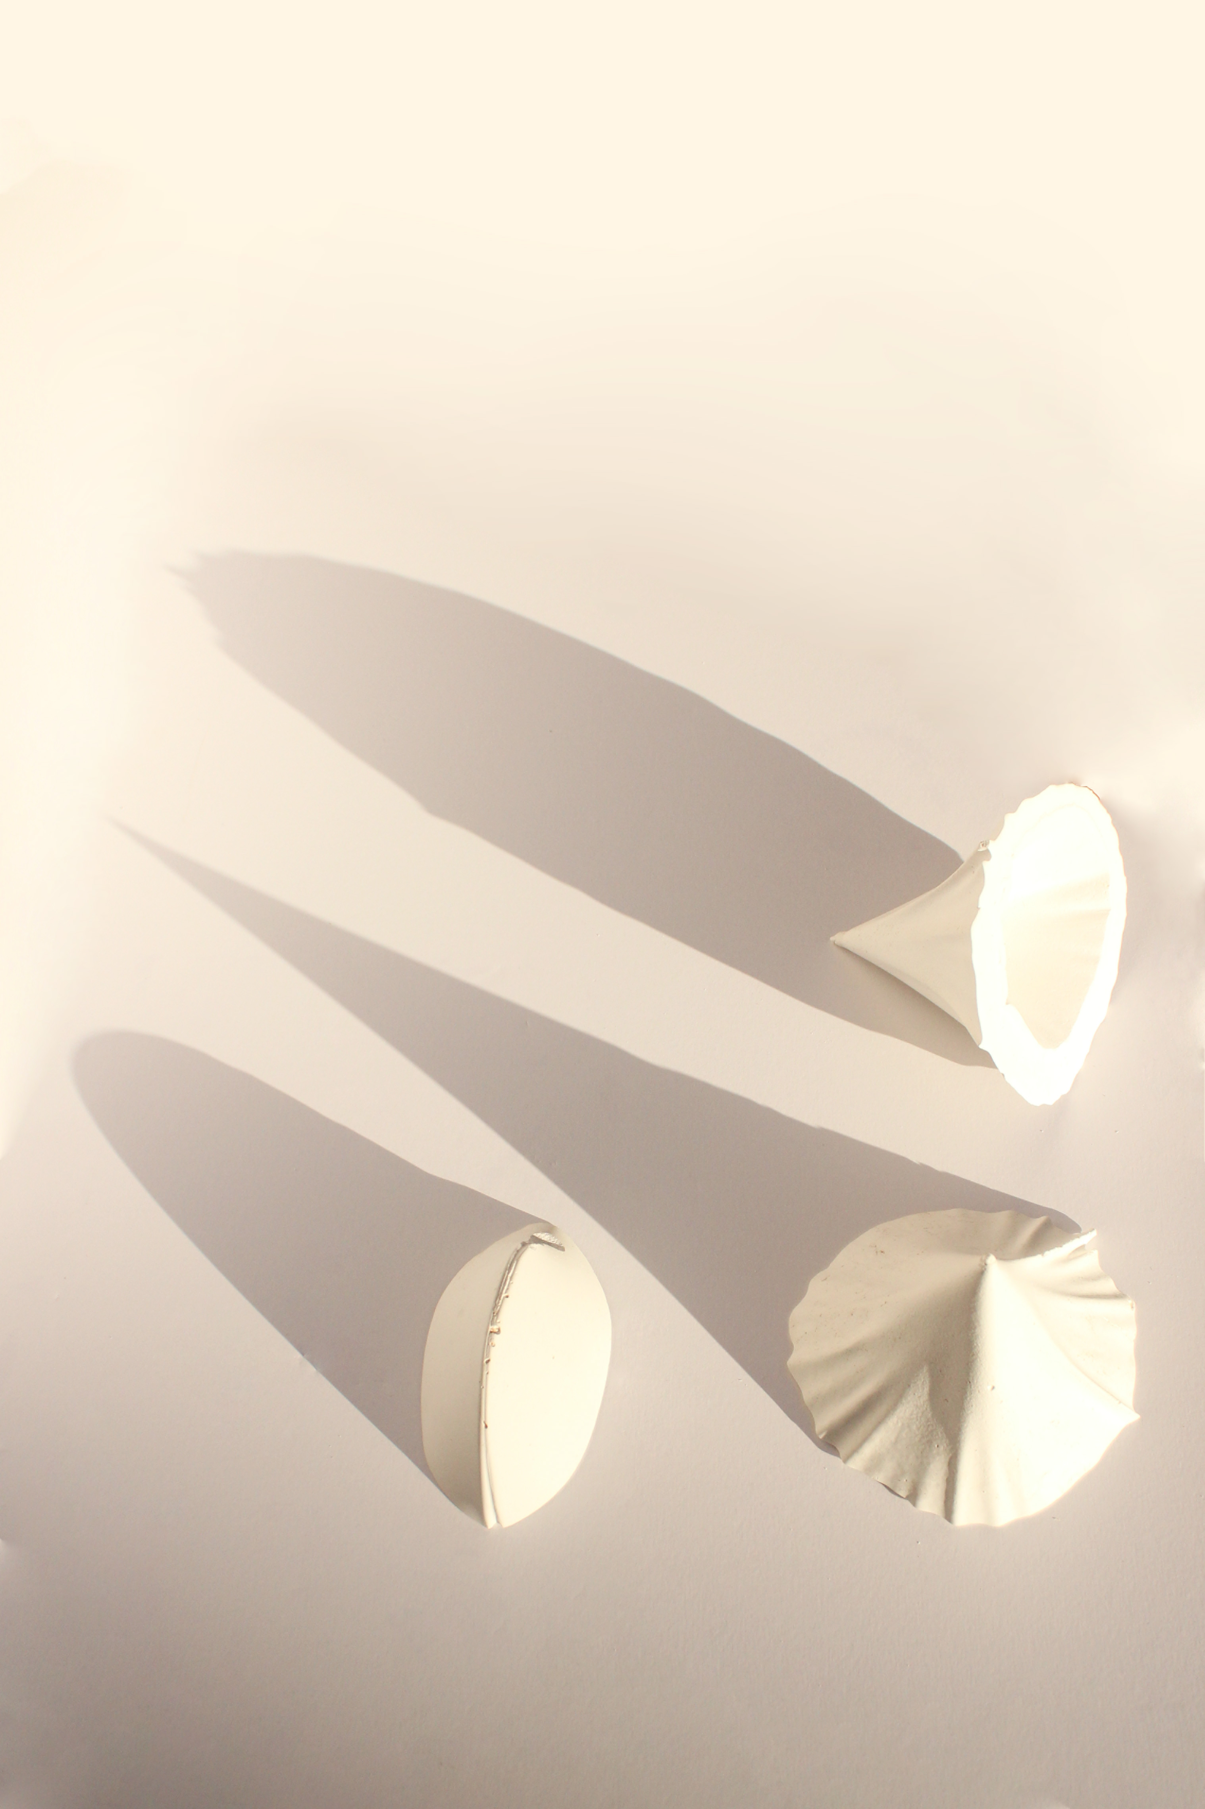
Conical Double Shells, Mariella Tzakis, Laura Veit, Fall 2018

