URBAN TRANSFORMATION / RAIL EDGE
City Diameter 2
Columbia GSAPP
Studio Buromoscow
Subject: Moscow central diameter, space development

Course structure

Block 1
4 weeks
Urban planning analysis of 12 railway sections, M 1:5000

Block 2
8 weeks
Development of the object, M 1: 500, M 1: 200

Travel Kinne week

Site visit Moscow
2 days workshop with March students

Problem description

There is a city of buildings, streets, squares and parks, city that we know and love. It is filled with life, it is complex and intense.

Within it there are enclaves that we do not know and do not see, hidden behind fences or cut off by railroads and highways, existing only on google maps. Some of these areas are so huge that they can fit in whole other cities.

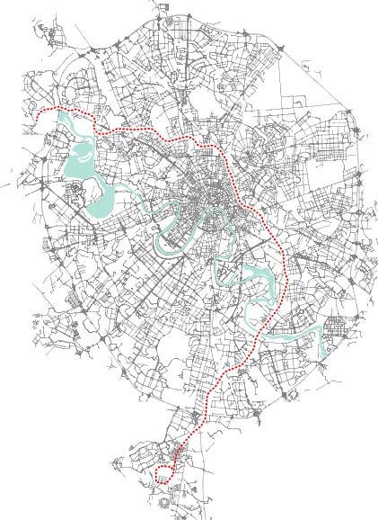

The area along railway route City Diameter 2 that cuts Moscow from northwest to the south equals in surface the state of Gibraltar. Soon this railway line will become a metro line. What used to be railway backyard will become urban frontage.

Let’s imagine what this frontage could be. Does I simply surrender to commercial development? Can its emptiness be valued and preserved? Will it connect the city or divide?
We will attempt to answer these questions by dividing the railroad in 12 plots, each student making a proposal for each one of them first on urban scale and then zoom into a building.
We will analize ruptured urban fabric, discuss the place of infrastructure in contemporaryn city, work with a range of scales from 1:5000 to 1:200, think of new functions and (mega) projects.

