ARCHA4844: URBAN PRESERVATION
Erik Langdalen, Conservation lab
10.17, 9am-11am/10.18, 6-8.30pm/10.19, 9am-11am /10.21, 9am-11am-4pm

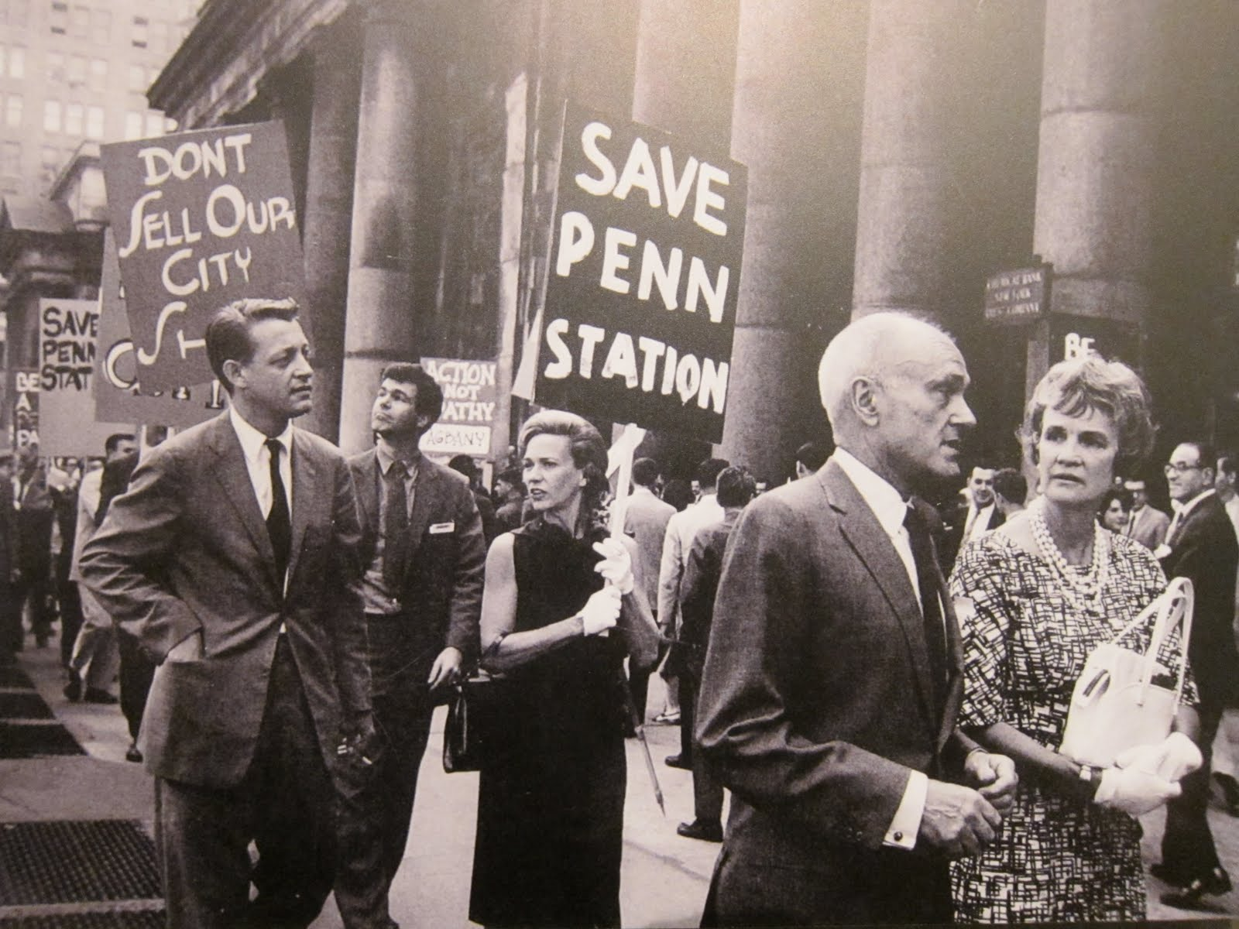

Preservation and progress are considered opposites. The discipline of preservation has since the early 20th century tried to withstand the massive urban development of our times, and since the 1920s been institutionalized according to international agreements and national legislation. It is therefore synonymous with governmental control - standing in the way for a free marked and individual freedom. In contrast to architecture and urban planning, preservation is not considered a creative practice – being left to safeguard the authenticity of already existing monuments.

Preservation was established to care for singular monuments, and is still struggling to tackle complexity: like heterogeneous urban areas, infrastructure and systems. As a consequence, preservation often falls short when faced with today’s urban planning processes. To ensure living, sustainable and intelligible cities, preservation needs to act more actively and precise - to speak and act differently, and to become a true creative and progressive practice.

The aim for this seminar is twofold: one is to detect experimental practices of urban preservation through time, the other is to search for ideas, principles and modes of operation that can guide us in the future. The class will discuss contemporary examples of experimental urban preservation in Europe and the US.

