“Wired Skins,” Research and Development and
Hands-On Design-Fabrication Workshop
Fall 2016

COLUMBIA GRADUATE SCHOOL OF ARCHITECTURE, PLANNING, AND PRESERVATION
Instructors: Todd Dalland, FAIA, tdalland@pvilion.com
Robert Lerner, AIA, rlerner@pvilion.com
Colin Touhey, EE, ctouhey@pvilion.com

Course Format: Presentations and Studio Project, Field Visits to Pvilion Design/Fabrication Workshop in DUMBO Brooklyn, Field Visits to local fabrication shops.
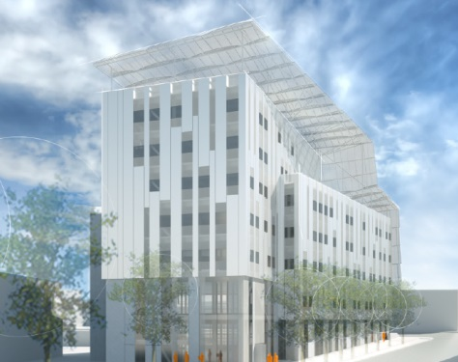
BACKGROUND
Building envelopes have evolved in recent years to provide more active and passive environmental controls. Reducing the mass of buildings has been a goal to make buildings more efficient structurally while meeting structural and environmental needs. Wired skins are performance membranes that can generate power, filter air for the building, or clean the air for the environment at large.
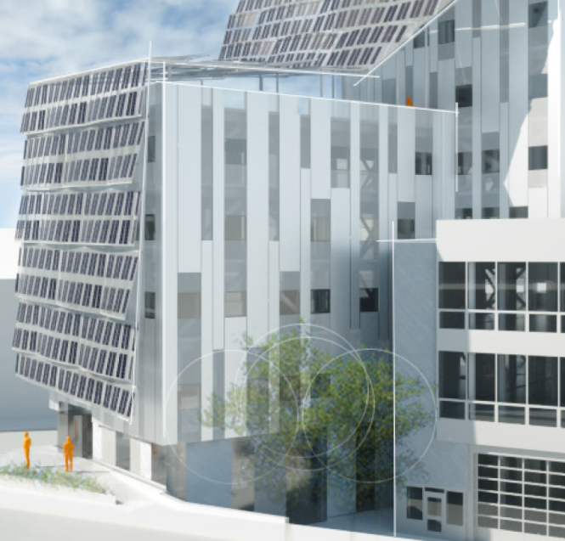
“WIRED SKINS” looks at the building skin as an active membrane, collecting energy, moving to respond to dynamic loads or solar orientations. The course will explore how new materials such as shape memory polymers, flexible photovoltaics, and industrial textiles can be employed to make building skins that are active, dynamic functionally and visually. We will take a hands-on approach to research and development, learning about materials and methods through fabrication and testing, devising test procedures and implement testing. While architects enjoy pushing the limits of technology, architectural fabricators are often key members of the design team, determining what is realistic technically, within project budgets and time frames. The course will focus upon developing the discipline of design from the fabricator’s point of view, by testing ideas in fabrication work-shop environment. Case studies will be presented by the instructors to demonstrate the role fabricators play in the design process with reference to current projects such as the new US Embassy in London, the new Artists for Humanity building in Boston, recent projects at Google’s Headquarters, and other projects. Students will research and present their own case studies of projects in which the expertise of the fabricator played a significant role in realizing the project.
COURSE REQUIREMENTS
Students are required to attend all classes and field trips, and participate in hands-on fabrication workshops. There will be three main assignments :
- Case study presentation: Each student will prepare a 10-15 minute presentation showing an example of a fabricator’s significant contribution to the realization of a complex design challenge. The Case Study, Class Participation and Attendance will account for 20% of the Course Grade
- Independent research: Each student will prepare a short paper on novel materials or methods of construction and implications for architectural applications. 20% of Course Grade
- Design, Fabricate, Build Project: This will be a group project involving design, fabrication and construction of an architectural product, project subcomponent, or subscale pavilion. 60% of Course Grade
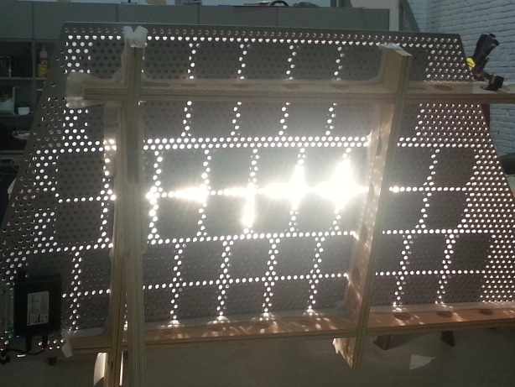
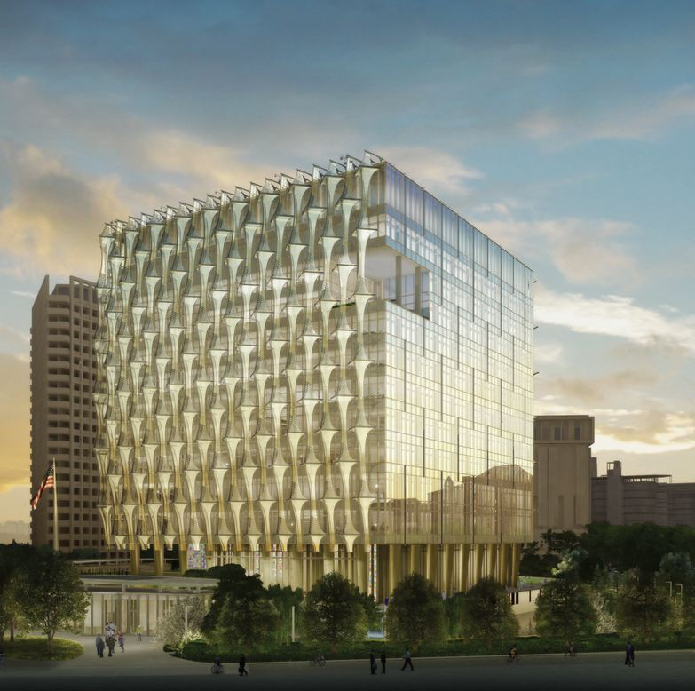
The new US Embassy in London, designed by Kieren-Timberlake. Fabrication design, engineering, testing, manufacturing and installation by Pvilion.

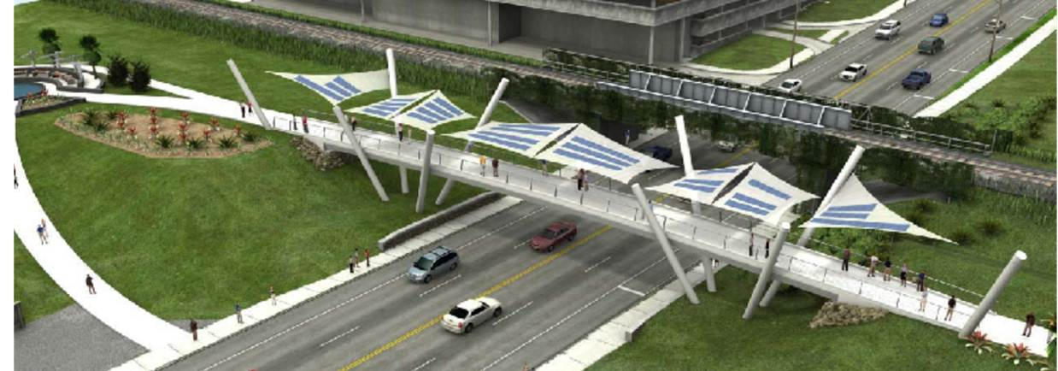
Capital Cascades Bridge, Tallahassee, FL. designed by Figg Bridge Group. Photovoltaic membrane design, engineering, testing and fabrication, by Pvilion.

SYLLABUS
Wk 1 Presentation: Course introduction, Instructor Introductions and Background, presentation on the work of Pvilion Inc. including firm history dating back to 1977, as tensile structure design engineering firm FTL Design Engineering, FTL Happold, FTL Solar, Pvilion. Wired Skins, introduction, current work and focus of the firm as designer/fabricator/builders. Introduce studio project topics, research and development topics. Open discussion about the state of the art of wired skins, membranes, fabrication, and research interests of presenters and students.
Wk 2 Presentation: Exploring the relationship between fabrication and design. Interface between digital design and hands-on fabrication. 3-d modeling, hands on model making, introduction to digital fabrication technologies, 3-d printing, cad cam milling, CNC, new technologies in materials and methods of fabricating, shape memory materials, active control technologies, smart materials. Research and Development as part of the designer/fabricators practice: Presentation of the research and development projects of instructors, including work for NASA, US Army, US Airforce, numerous commercial clients, NYSERDA, and many others. This R&D presentation will include case studies in: high and low pressure air beams, the advanced inflatable airlock for NASA, flexible photovoltaics, the US Embassy in London – Photovoltaic Screens. We will introduce numerous research and development topics which may be pursued by student teams as part of the course project. Assignment: Case Study in which a fabricator solved a key design problem on an architectural project.
Wk 3 Hands-on Design Workshop at Pvilion Workshop, Dumbo, Bklyn. Instructors will demonstrate tensile structures model making techniques, fabrication techniques, photovoltaic lamination methods, physical and electrical testing techniques.
Wk 4 Student project discussions: Students will present their ideas for their projects. Each student will present concept(s) for development over the course of the studio. The class projects will evolve into a number of group projects involving fabrication of large scale pieces, however every student will present design concepts to the class for discussion. A “down-select” process will take place in which a few projects will advance to prototyping and fabrication.
Wk 5 Field trip to Fabrication Shop: Pviion will organize a field trip to a fabrication shop in the tri-state area to observe cad-cam manufacturing processes such as: waterjet cutting, plasma cutting, laser cutting, milling, etc.
Wk 6 -7 Students shall present project drawings, detail drawings, physical models, cad models, and 3-d printed models for review by instructors.
Wk 8 Conceptual design review of student projects: drawings, models, research and development, proposed tests. Fabrication work session at Pvilion studio in DUMBO.
Wk 9 Design development review of student projects: drawings, models, test fixtures.
Wk 10 Design review of student projects: progress review, interim pin up with guest critics.
Wk 11 Design review of student projects, at Columbia and Pvilion workshop.
Wk 12 Design review of student projects, at Columbia and Pvilion workshop.
Wk 13 Final Project Review
Guest Critics: Craig Schwitter Buro Happold
David Bott Heintges & Associates
Peter Yeadon Yeadon Space Agency
James Carpenter James Carpenter Design Associates
Kai-Uwe Bergman BIG Architects

