Columbia University GSAPP
Fall 2016
Advanced Studio V

Gregg Pasquarelli, critic
Angelica Bacon, TA

The Space of the Wall
Reconceiving the urban stadium

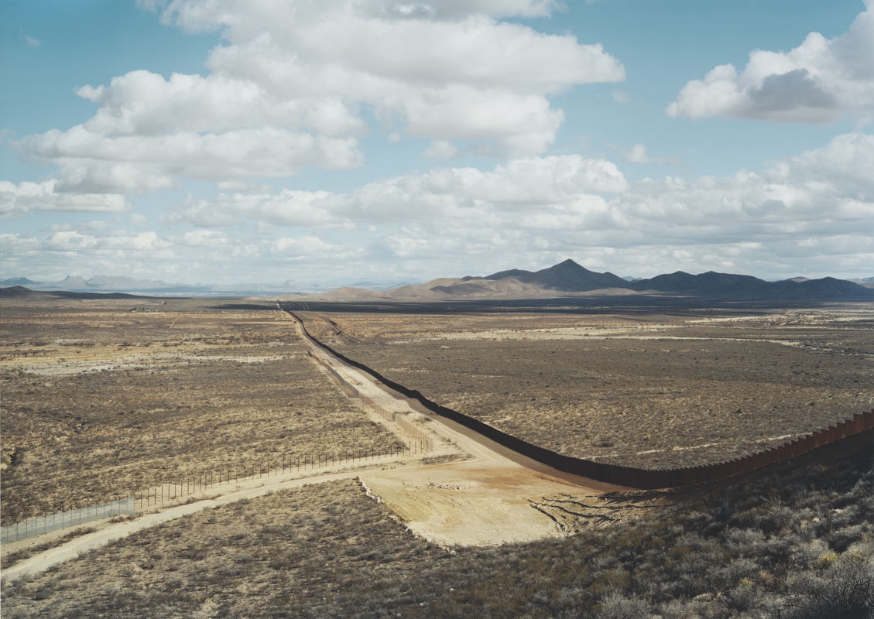

1. abstract

Architects today imagine, and like to profess, that the nature and scope of architecture has profoundly changed. We tell ourselves that we are facing problems unknown in previous eras and tackling them with spatial and technological solutions that would have been unimaginable only a few years back. Sometimes this is true. But even when the programmatic demands on a space are a direct reflection of the most rarefied contemporary sociologies, even when a project is analyzed and delivered through the most magical tech, certain fundamentals hold. There is gravity. There is weather. There is outside and, more often than not, there is inside, too. There is the need to enclose and protect. The need to modulate experience. The need to distinguish one thing from the other. The need to shelter. The need to divide. No matter how gossamer the material we may choose to render them in, no matter how transparent the glass—and irrespective of the infinity of forms they may take—architects make walls.

Our studio will be an examination of this architectural essential. By challenging the wall, we will come to know its possibilities. By questioning the wall, we will master its potential. By accepting the wall, we will open ourselves to experiencing all the gray areas within it.

2. program

The architecture of cities can be defined as the strategic (or expressive, or opportunistic) manipulation of edges, surfaces, and apertures to define and enable certain human relationships—in other words, we build our walls and then our walls build us. In this context, however, the unbroken wall, the brutal wall, the pure wall, is widely accepted to be a city-killer: denying interaction, deadening sidewalks, inviting vandalism, ennui, and neglect. Of all the programs we design into our cities, the stadium/arena presents among the greatest challenges in this regard. An inversion of the preferred focus of urban attention, enclosed spaces for gathering, at scale, tend to present the most impenetrable and problematic surfaces to the street. At the same time, the demands placed on walls in the urban stadium—to invite entry, sometimes in great numbers, while protecting the nature and functions of the spaces within, make the urban stadium and ideal programmatic setting in which to explore this perennial question.

We will interrogate the idea of the wall in order to learn to control it. How can the thickness of the wall, the space of the wall itself, be tuned to perform at its maximum potential in the challenging condition of the urban stadium edge? When should we resolve to fight the blankness? And when should we learn to love it? What programs can be inserted in the wall to change both the internal and external effects.

Sites will be multiple, and distributed throughout New York City. Programmatic requirements will vary across projects, but will be confined to a selection of approved sports. All projects, however, will be asked to solve the essential question posed by this typology: how does one use the thickness of the wall to effect a transposition of attention from the street to a stadium's space of action or performance? Or, how can a wall invert our experience of the city?

3. procedure

The studio will begin with a re-examination of Paul Virilio’s Bunker Archaeology as a kick off to a one-week topological study of surfaces in order to create a performative wall on the border of the US and Mexico. We will study methods of enabling passage and insertion of program to have specific effects. The studio will then study the performative constructs of sports design and observation to create a parametric model in Grasshopper to allow each model to change based on various sports. The same will be done with the context selected by the students to test how the urban environment effects the stadium. Finally, additional programs will be designed into the thickened wall to make a complex, urban, mixed-use engine for the city.
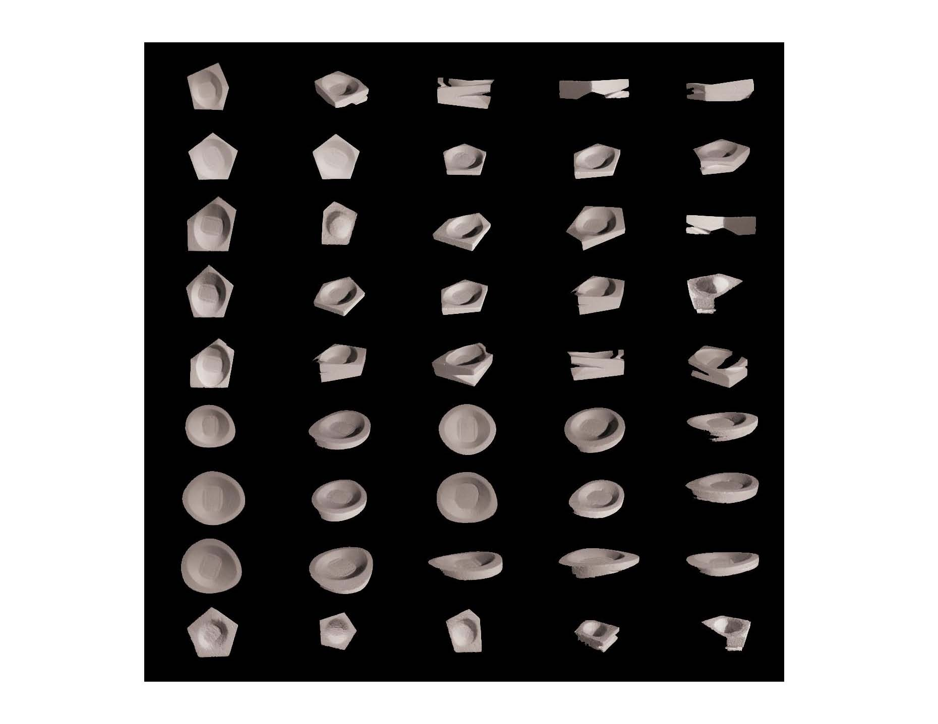
4 modeling

It is expected that the students extract their designs from the parametric models and create multiple physical models while researching various fabrication techniques. Both drawing and making will be equally emphasized and large scale execution of the stadium wall is essential to understanding the project.

