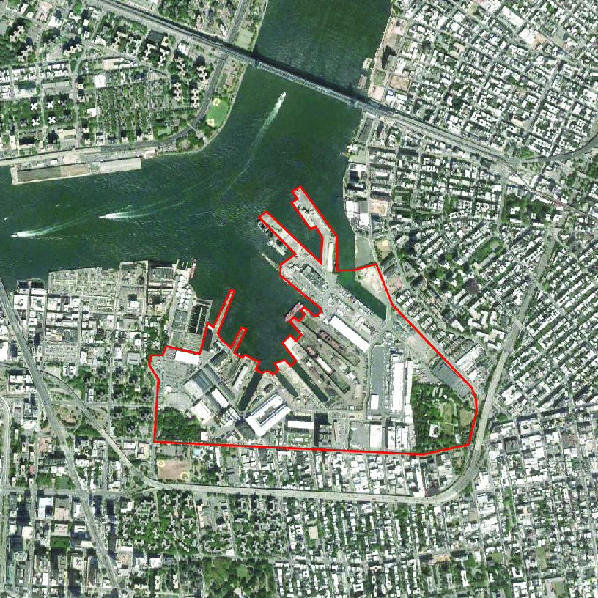

THE WORK STUDIO
Speculating on the Future of Work at the Brooklyn Navy Yard

Introduction

What about WORK?

The Brooklyn Navy Yard is no longer a vestige of what New York once was, instead the Yard has become emblematic of how New York will adapt and transform toward the future. Its core mission—“to build and diversify our city’s employment base”—is essential not only to foster growth, but to promote types of growth that are broadly more equitable and more ecological.

In the last few decades the geography of New York City has transformed in ways that are unrecognizable. Who would have imagined twenty years ago a city in which people regularly lived and worked in Brooklyn, yet visited Midtown only once every six months? In fact, most workers no longer commuted into a central business district.

It is possible, that instead, Brooklyn has taken the lead in redefining New York today. The city’s production landscape is expanding, once again, a shift that is reminiscent of a history of urban industrialization; this focus on production is spreading across the boroughs in a new way that promotes live, work and play across a network of nodes. The Brooklyn Navy Yard, Flatiron, Industry City, DUMBO, Long Island City and other neighborhoods are at the center of this activity, with more developing at Manhattanville and Cornell Tech.

The agenda for this studio is to produce real possible future designs for this New York City site, envisioning new forms of working and collective urbanism for NYC dwellers. Students will speculate with large-scale and small-scale drivers that may enable new forms of energy production, environmental resiliency, public policy, technology, transportation, etc.

On Speculation
Speculation will frame the work this semester as we consider the nature of taking a very large risk.
Speculation by definition is both the process of thinking or meditating on a subject, a judgment, conclusion, opinion, or theory reached by conjecture – as well as – an investment involving higher than normal risk in order to obtain a higher than normal return (not strictly monetarily).
Speculation may involve taking large risks especially with respect to making predictions for the future, and gambling, in the hopes of making huge gains (again, not strictly monetary).

On Collective Urbanism

Collective – Collective is our term for shared and public space. Collective space is to be considered a critical piece of infrastructure to enable work and play. Collective space encompasses a variety of scales, and is an essential and strategic component for developing urbanism. Students will investigate and propose programs for their collective space strategy.

On Work

Students will rethink the future of the workplace, and consider how work might
inform their speculative models for collective urbanism. What form does this work take as the
concept of work evolves? One example of a new form of work is an incubator, “a place or situation that permits or encourages the formation and development of new ideas” (definition, Webster’s Dictionary). Another example is vertical manufacturing.

On Modeling

We will make a lot of models, both conceptual and physical. Students will develop and test new conceptual models on the future of work using physical modeling as the primary mode of study and speculation. In this studio, research and design will be conducted from the onset. Research will not strictly operate as a collection of information; instead research will be performed and conducted as students test and experiment with formal and urban strategies.

On Drawing

Students should refrain from producing the ultra-realistic renderings that became popular during the boom in exchange for thoughtful and critical representational techniques, ideally reflecting their subject matter—informing and informed by the concept.

It is important to consider “all media as dead media”, as Alex Galloway suggests. As architects construct futures, we might avoid capitalist realist representations, to instead participate in a process of recombining material and representational motifs—those that are not restricted to current technologies, which are inherently and already aging.

In this studio, we will also be mindful of the full breadth of presentation composition. This includes typesetting, copy editing (no typos), and testing various formats to effectively communicate our ideas.

Format

The class will analyze and share information on this complex and extra-large-scale urban environment, looking at it from many trajectories: historical, environmental, economic, technological, political, and cultural.

Early in the semester the studio will participate in a workshop with The Extrapolation Factory at the New Lab in the Brooklyn Navy Yard—learning new tools and techniques for imagining future scenarios that might inform the Navy Yard’s evolution. Moving forward, integrating these tools into the studio process, students will develop and design a research report/book for the Mid-Review that will speculate on their project drivers.

Following the Mid-Review, students will develop a piece of their project at a larger scale along with a final version of their project booklet at the Final Review.

Partial Bibliography

www.brooklynnavyyard.org/the-navy-yard/history/
www.extrapolationfactory.com
Rappaport, Nina, Vertical Urban Factory (Actar, July 15, 2016)
Darly, Gillian, Factory (Reaktion Books, September 3, 2004)

